Entry Criteria, Exit Criteria and Acceptance Criteria
# Source: AI Source: Provided by: [Data Path: Persons Table -> ID Column: 1, Name_En Column: Motasem Essam] -> From: [ChatGPT] on [8/22/2025]
Great 👌 — these three terms (Entry Criteria, Exit Criteria, Acceptance Criteria) often sound similar but mean different things in software testing. Let’s break them down clearly:

1️⃣ Entry Criteria

📌 Definition
# Source: AI Source: Provided by: [Data Path: Persons Table -> ID Column: 1, Name_En Column: Motasem Essam] -> From: [ChatGPT] on [8/22/2025]
The preconditions that must be met before testing can begin.
It ensures that the test team doesn’t start testing until the environment, code, and resources are ready.

✅ Examples
# Source: AI Source: Provided by: [Data Path: Persons Table -> ID Column: 1, Name_En Column: Motasem Essam] -> From: [ChatGPT] on [8/22/2025]
- Requirements are signed off.
- Test environment is set up.
- Test data is prepared.
- Test cases are reviewed and approved.
- Build is deployed successfully.
👉 Simple Example: Before functional testing of a “Login Feature,” the entry criteria could be:
- Login page is developed and unit-tested.
- Test environment is up and stable.
- Test cases for login are ready.

Definition of Ready
# Source: AI Source: Provided by: [Data Path: Persons Table -> ID Column: 1, Name_En Column: Motasem Essam] -> From: [ChatGPT] on [8/22/2025]
Definition of Ready (DoR) in Agile is a set of clear conditions or criteria that a User Story (or backlog item) must meet before the team can start working on it in development or testing.

📌 Key Points about DoR:
- It’s an entry criterion for a sprint/iteration.
- Ensures that the backlog item is well-prepared, clear, and feasible for the team to work on.
- Helps avoid confusion, rework, and wasted effort once the sprint begins.
- Provides a shared understanding between Product Owner, testers, and developers about when a story is truly ready.

✅ Examples of DoR:
A User Story is Ready when:
- It is clearly defined and understandable by the team.
- Acceptance Criteria are written and testable.
- Dependencies are identified and manageable.
- Priority and business value are clear.
- The story has been estimated by the team.
- Required test data, environments, or tools are available.

🔑 In short:
The Definition of Ready makes sure the team doesn’t start a story that’s vague, incomplete, or not testable. It reduces risk and sets the stage for smoother development and testing.

2️⃣ Exit Criteria

📌 Definition
# Source: AI Source: Provided by: [Data Path: Persons Table -> ID Column: 1, Name_En Column: Motasem Essam] -> From: [ChatGPT] on [8/22/2025]
Exit criteria (also called test completion criteria) are The conditions that must be met before testing can be considered complete.
It ensures that testing has achieved its goals before moving to the next phase (or releasing).

✅ Examples
# Source: AI Source: Provided by: [Data Path: Persons Table -> ID Column: 1, Name_En Column: Motasem Essam] -> From: [ChatGPT] on [8/22/2025]
- All planned test cases executed.
- 95% of test cases passed.
- No open Severity-1 or Severity-2 defects.
- Test coverage ≥ 90%.
- Test summary report prepared and signed off.
👉 Simple Example: For the “Login Feature,” the exit criteria could be:
- All login test cases executed and passed.
- No critical login defects remain open.
- Regression tests for login completed successfully.

Definition of Done
# Source: AI Source: Provided by: [Data Path: Persons Table -> ID Column: 1, Name_En Column: Motasem Essam] -> From: [ChatGPT] on [8/22/2025]
Definition of Done (DoD) in Agile is a shared agreement within the team that clearly defines the conditions a product backlog item (e.g., a user story, feature, or task) must meet to be considered complete and releasable.

📌 Key Points about DoD:
- It’s an exit criterion for development and testing.
- Ensures transparency: everyone (team, Product Owner, stakeholders) has the same understanding of what “done” means.
- Provides objective quality checks before delivering an increment.
- Helps avoid misunderstandings like “it works on my machine” or “code is done but not tested.”

✅ Examples of DoD:
A user story is Done when:
- All acceptance criteria are met.
- Code is written, reviewed, and merged.
- Unit and integration tests are implemented and passed.
- Regression tests are executed with no critical defects.
- Documentation (if required) is updated.
- The increment is potentially shippable/releasable.

🔑 In short:
The Definition of Done is a checklist that ensures the team delivers high-quality, completed work that could be released to users at the end of the iteration/sprint.

3️⃣ Acceptance Criteria

📌 Definition
# Source: AI Source: Provided by: [Data Path: Persons Table -> ID Column: 1, Name_En Column: Motasem Essam] -> From: [ChatGPT] on [8/22/2025]
The conditions that a software product must meet to be accepted by the customer/business.
It is defined for each user story or requirement and is business-focused (not just testing-focused).
- Used in Agile: part of user stories.
- Ensures the feature delivers business value.

✅ Examples
# Source: AI Source: Provided by: [Data Path: Persons Table -> ID Column: 1, Name_En Column: Motasem Essam] -> From: [ChatGPT] on [8/22/2025]
- User Story: “As a user, I want to log in to the website so that I can access my account.”
- Acceptance Criteria:
  - User can log in with valid username & password.
  - Error message is displayed for invalid credentials.
  - Account locks after 3 failed attempts.
  - Login works across Chrome, Firefox, and Safari.
👉 Simple Example: If a “Payment Feature” is developed, the acceptance criteria could be:
- Payment succeeds with valid credit card.
- Error is shown for expired card.
- Transaction receipt is generated.

📌 Ways to Write Acceptance Criteria for User Stories

1. Checklist Style
# Source: AI Source: Provided by: [Data Path: Persons Table -> ID Column: 1, Name_En Column: Motasem Essam] -> From: [ChatGPT] on [8/22/2025]
👉 Simple list of rules or conditions that must be true for the story to be considered complete.
Example (Password Reset):
- System must send reset link to user’s email.
- Reset link must expire after 24 hours.
- New password must have at least 8 characters.
- Password must include at least one number and one letter.
Example (Shopping Cart):
- Users can add items to the cart.
- Users can remove items from the cart.
- Cart updates total price automatically.
- Cart prevents checkout when empty.
✅ Best For: Quick checks, QA teams, rule-heavy features.

2. Scenario-Oriented (Given–When–Then / Gherkin Style)
# Source: AI Source: Provided by: [Data Path: Persons Table -> ID Column: 1, Name_En Column: Motasem Essam] -> From: [ChatGPT] on [8/22/2025]
👉 Behavior described as scenarios.
Example (Login):
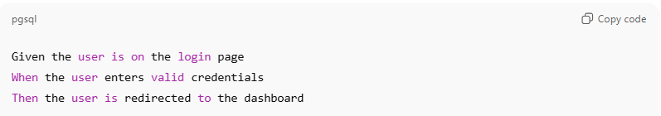
Given the user is on the login page
When the user enters valid credentials
Then the user is redirected to the dashboard
✅ Best For: BDD, automation, stakeholder-friendly.

3. Use Case-Oriented Style
# Source: AI Source: Provided by: [Data Path: Persons Table -> ID Column: 1, Name_En Column: Motasem Essam] -> From: [ChatGPT] on [8/22/2025]
👉 Acceptance criteria follow main + alternative flows.
Example (Checkout):
- Main Flow: User enters payment → payment succeeds → order confirmed.
- Alternative Flow: Payment fails → system shows retry option.
✅ Best For: Capturing happy path + edge cases.

4. State/Condition-Oriented Style
# Source: AI Source: Provided by: [Data Path: Persons Table -> ID Column: 1, Name_En Column: Motasem Essam] -> From: [ChatGPT] on [8/22/2025]
👉 Focuses on system states and conditions.
Example (Cart):
- If cart is empty → checkout disabled.
- If item out of stock → cannot be added.
- If payment succeeds → status = Confirmed.
✅ Best For: Systems with multiple state transitions.

📊 Comparison Table
# Source: AI Source: Provided by: [Data Path: Persons Table -> ID Column: 1, Name_En Column: Motasem Essam] -> From: [ChatGPT] on [8/22/2025]
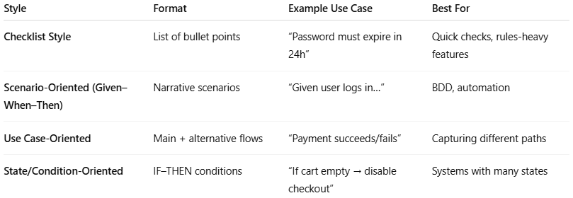
Style | Format | Example Use Case | Best For
Checklist Style | List of bullet points | “Password must expire in 24h” | Quick checks, rules-heavy features
Scenario-Oriented (Given–When–Then) | Narrative scenarios | “Given user logs in…” | BDD, automation
Use Case-Oriented | Main + alternative flows | “Payment succeeds/fails” | Capturing different paths
State/Condition-Oriented | IF–THEN conditions | “If cart empty → disable checkout” | Systems with many states

🔑 Key Difference Between Them
# Source: AI Source: Provided by: [Data Path: Persons Table -> ID Column: 1, Name_En Column: Motasem Essam] -> From: [ChatGPT] on [8/22/2025]
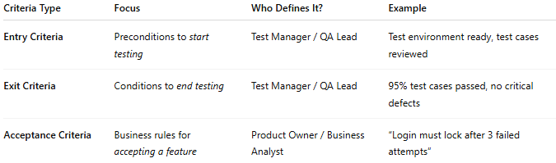
Criteria Type | Focus | Who Defines It? | Example
Entry Criteria | Preconditions to start testing | Test Manager / QA Lead | Test environment ready, test cases reviewed
Exit Criteria | Conditions to end testing | Test Manager / QA Lead | 95% test cases passed, no critical defects
Acceptance Criteria | Business rules for accepting a feature | Product Owner / Business Analyst | “Login must lock after 3 failed attempts”

✅ In short:
- Entry Criteria = "When can we start testing?"
- Exit Criteria = "When can we stop testing?"
- Acceptance Criteria = "What conditions must be met for the customer to accept the feature?"

